**VICTORIOUS EDUCATION SERVICES**

**P.5 SCIENCE LESSON NOTES**

**Topic 1**

**KEPPING POULTRY AND BEES**

***Lesson 1***

**Poultry and poultry keeping**

Poultry refers to all kinds of domestic birds kept for a purpose.

**Examples**: Chicken, Turkeys, Ducks, Geese, Doves Guinea fowls etc.

***Poultry keeping*** refers to the rearing of domestic birds or fowls.

**Why do people rear poultry**?

* For meat and egg production eggs and meat are good sources of proteins to our bodies.
* People keep poultry for cultural purposes like dowry, rituals
* Poultry keeping is a source of income and employment

***Terms used in Poultry rearing***

* *Hen* – Adult female chicken.
* *Cock*- Adult male chicken.
* *Cockerel* – Young male chicken from 8 weeks onwards.
* *Capon* – castrated cock.
* *Pullet* – Young female chicken.
* *Chick* – Young one of a hen.
* *Incubation* – The process by which an egg is given necessary conditions to hatch into a chick.
* *Moulting* – the process by which birds shed their feathers to replace them with new ones.
* *Culling* – removal of unproductive or unhealthy birds from a flock.
* *Brooding* – giving special care to young chicks.
* *Brooder* – special structure where special care is provided to chicks.
* *Debeaking* – is the shortening of the upper part of the bird’s beak.

***Lesson 2***

**External features of a bird Diagram**

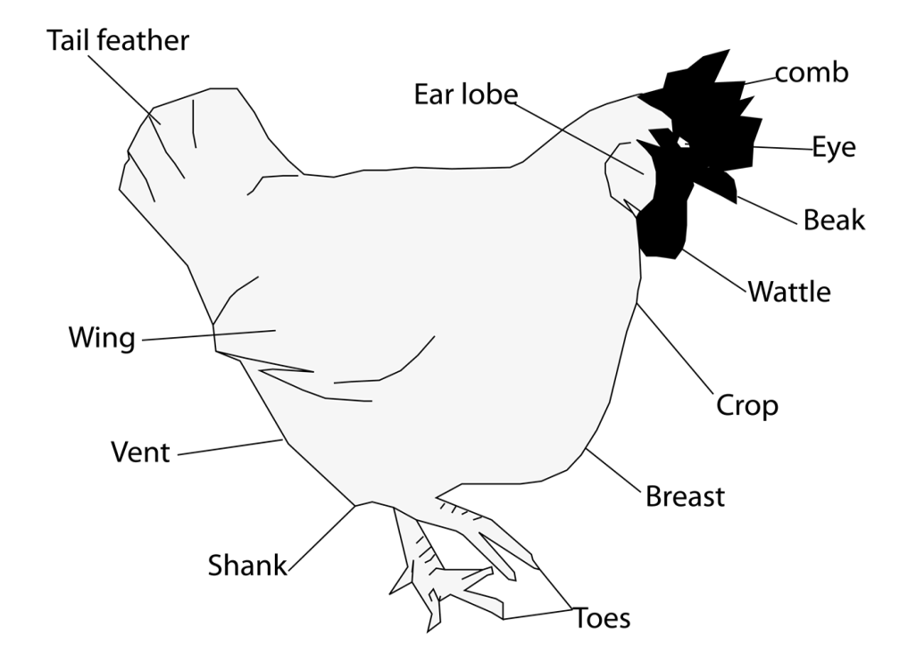

**Functions of the parts**

***Comb*** and ***Wattle*–** attracts the opposite sex**.**

***Spur***- for protection or defense

***Beak*** – picking food and protection / support the bird during mating.

Feathers:

* Keep the bird warm.
* Cover the body of a bird to protect it from physical injury.
* Enable birds to fly.
* Provide shape and colour for easy identification.  
  Spur

**Difference between a hen and a cock**

A hen has a small comb and wattle on its head while a cock has a big comb and wattle.

A cock has a long spur than that of a hen.

A cock has a long tail feathers than those of a hen.

A cock has brightly hackle feathers than those of a hen.

*Activity*

***Lesson 3***

**Types of feathers:**

Quill feathers, body feather,filoplume, convert feathers

**Structures of feathers**

***a) Quill feather***

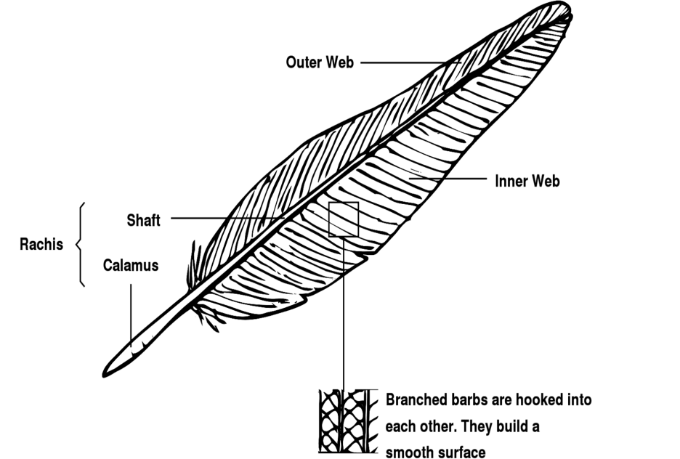Most quill feathers are found on the wings. So they help the bird during flight.

*Features of a quill feather*

***b) Covert feather***

These feathers help to keep the bird’s body warm.

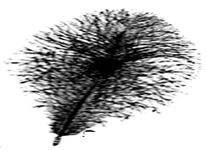

***c) Filoplume feather***

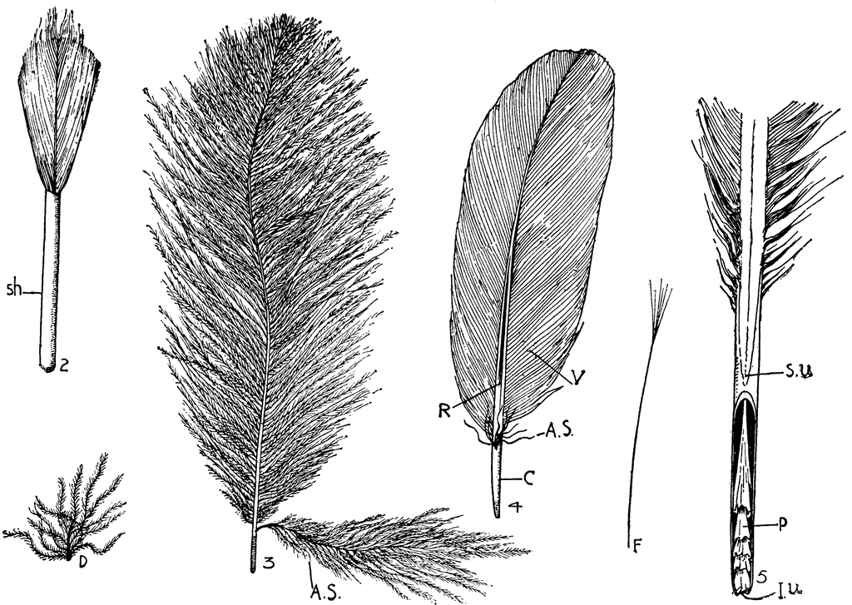These are the tiniest feathers on the bird’s body.



***d) Body feather***

These are the first feathers to develop on the bird’s body. They insulate the bird’s body against heat loss.

***Lesson 4***

**Types of Chicken**

A type of chicken means a class of birds kept for a special purpose.

***Type Purpose***

1. **Layers (**light breeds) - kept for egg production (laying eggs) e.g the white leg horn, the brown egger, Ancona
2. **Broilers** (Heavy breeds)/ table birds - kept for meat production e.g Light Sussex, the Ply mouth rock.
3. **Dual Purpose**- kept for both meat and egg production e.g New Hampshire, Rhode Island Red.

**Breeds of Chicken**

A breed is a group of birds with similar characteristics. There are three types of breeds of poultry, namely;

1. **Local breed**

These are the ones that have been kept in Uganda for a long period of time.

**Characteristics of Local breeds**

* They are more resistant to diseases and parasites.
* They can withstand harsh climatic conditions than the exotic.
* They have a slow growth rate.
* They lay small and only a few eggs during each laying season.
* They look after their young ones.
* They incubate their eggs.
* They are multi colour.
* They feed themselves.

**NB**:Local breeds can be improved by cross breeding. Cross breeding improves their quality of performance.

***Lesson 5***

1. **Exotic breeds**

These are breeds that have been imported into Uganda.

**Examples of exotic breeds of chicken;**

* White leghorn**.**
* Rhode Island Red
* New Hampshire Red
* Light Sussex
* Ancona
* Black Australorp

**Characteristics of exotic breeds**

* They grow and mature in a short time
* They produce many eggs
* They need a lot of care like feeding,vaccination andproper shelter.
* They do not incubate their eggs.
* They are easily attacked by diseases.
* Each breed has its own colour i.e. red,brown,and white.
* They are easily affected by bad weather conditions like strong sun shine, rain and coldness.

1. **Cross breeds**

These are obtained by mating a local breed with an exotic breed.

**NOTE: When two pure exotic breeds mate, they produce *a hybrid*.**

***Advantages of keeping local breed over exotic breeds and vice versa***

* Local breeds are resistant to tropical diseases unlike the exotic breeds.
* Local breeds can survive poor management conditions like poor feeding,poor housing e.t.c
* Local breeds can withstand harsh weather conditions compared to the exotic ones.

*Activity*

***Lesson 6***

**Reproduction in Birds**

Birds reproduce by laying eggs which are fertilized internally. A hen lays fertilized eggs which are incubated for 21 days to hatch into chicks.

**Internal structure of an egg (diagram)**

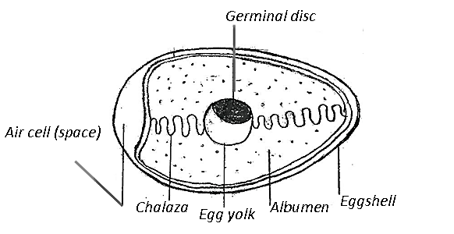

**Functions of each part**

***The shell***- protects the inner egg content

* Allows gaseous exchange since its porous.
* It’s made of mineral salt called calcium

***Chalaza*** - holds the yolk and embryo in position

***Yolk*** - source of proteins and fats for the embryo

***Germinal disc*** – develops into chick.

***Albumen*** – source of protein and water to growing embryo

***Air space*** – keeps and provides fresh air to the embryo.

***Activity***

***Lesson 7***

**Incubation**

Incubation is the process by which an egg is given necessary conditions to hatch into chick.

**An incubator** is a machine used to hatch eggs.

**Incubation period of some domestic birds**

Bird Incubation period

Chicken 21 days

Ducks 28 days

Turkey 28 days

Pigeons 16 days

Geese and Pigeons 30 days

**Types of Incubation**

1. **Natural incubation:**

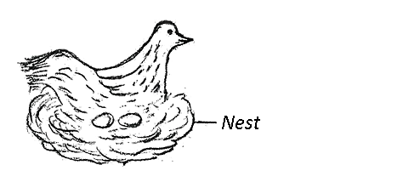This is where a mother hen lays eggs, turns broody and sits on them for 21 days to hatch out chicks.

**Advantages of natural incubation**

* It is cheap to maintain and manageable
* There is little attention to the incubating hen
* The chicks get extra care from the mother.

**Disadvantages of natural incubation**

* Few chicks are hatched at a time.
* The broody hen can easily be attacked by Vermin
* The hen used may not be good at incubating.

1. **Artificial incubation**

This is a method where an incubator machine is used to hatch the eggs.

Some incubators use a lamp to supply heat while others use electricity

An electric incubator

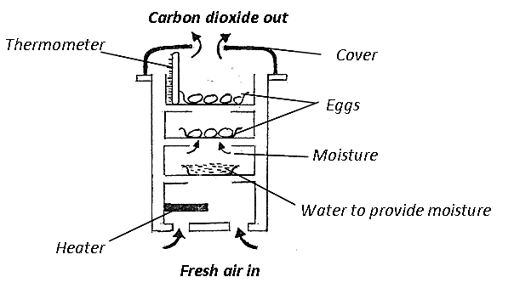

**Advantages of Artificial incubation**

1. Very many eggs can be hatched at the same time
2. Artificial incubation can be used for commercial purpose
3. Eggs are free from vermins.

**Disadvantages of Artificial incubation**

1. It is an expensive method to manage
2. It needs special attention and care
3. There must be someone skilled to always supervise it.

***Activity***

***Lesson 8***

**Brooding Chicks**

Brooding is the giving of special care to chicks from the time of hatching to nearly eight weeks.

**Types of Brooding**

1. **Natural Brooding**

This is where a mother hen provides warmth, security care and food to young chicks.

**Advantages of natural brooding**

* It is cheap in terms of expense and attention.
* The hen looks for food for its chicks.
* The hen provides security for the chicks.
* Toe-pecking is reduced in chicks because they move their mother.

**Disadvantages of natural brooding**

* Loss of chicks due to poor protection against predators
* It cannot be done on large scale
* In case of death of mother bird, chicks will be left without care.

1. **Artificial brooding**

This is where chicks are looked after while in a brooder.Abrooder is a special structure(house) for keeping chicks below the age of 8weeks.

**Advantages of artificial brooding**

* Chicks are protected from predators.
* It can be used for commercial purposes.
* It is easier to feed chicks from one place.

**Disadvantages of artificial brooding**

* It is expensive to buy feeds for chicks
* The chicks need constant and a special person to look after them
* Toe- pecking among the chicks is difficult to control
* Chicks can die if there isn’t enough heat and warmth.

**Types of Brooders**

1. Kerosene brooder.

This is the one that uses a kerosene lantern to provide warmth to the chicks.

1. Infra-red brooder.

This uses infrared lamp to provide warmth to chicks.

The advantage of kerosene brooder over infrared brooder is that it is cheaper.

Disadvantages of a kerosene (paraffin) brooder

* It needs a lot of close attention.
* Lamp without guards can burn the chicks.
* Soot from the lamp can accumulate in the brooder.

**Structure of an infrared brooderKerosene brooder**

*Activity*

***Lesson 9***

**FEEDING CHICKEN**

The Food(Mash) given to birds must always be put in clean feeding troughs and clean water in the water trough.

**Diagrams to show water trough and feeding trough**

**Poultry feeds**

**Age** **Type of feeds (Mash)**

1 day – 8 weeks - Chick mash (for faster growth)

8weeks – 16 weeks - Grower’s mash (layers)

Broilers after 18 weeks - Broiler’s mash

Layers after 18 weeks - Layer’s mash

**NB:** Laying birds should be given greens to supply vitamins, mineral salts and to keep them busy to reduce poultry vices. Birds should be given feeds with stones to help in crushing food during the process of digestion.

**Digestive system of a domestic fowl**

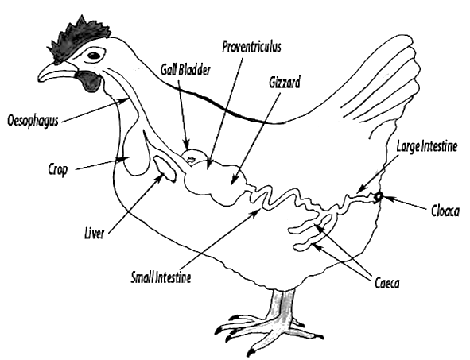**Functions of each part**

***Beak*** - Picks/peck food

***Gullet*** - Passes food to the crop

***Crop*** - Stores, moistens and softens food

***Gizzard*** - Food is crushed into small particles by the use of stones (grits)

***Small intestines*** –Digestion is completed here and digested food is absorbed into the blood stream.

***Large intestines*** – Absorption of water takes place here.

***Vent*** - passes out waste product/acts as sexual organ for the bird.

***Activity***

***Lesson 10***

**SYSTEMS OF POULTRY KEEPING**

1. **Free range system (open range system)**

In this system, birds are left freely to move and feed themselves without being confined in a room.

**Advantages of free range system**

* It cuts down feeding costs as the birds look for their own food
* The birds eat a balanced diet from natural sources
* The birds get enough exercise

**Disadvantages of Free range system**

* Eggs are difficult to collect or may be lost easily
* Birds can easily be eaten by predators.
* It’s difficult to control pests and diseases.
* Record keeping of individual birds is difficult
* Birds can easily stray and destroy crops

1. **Deep Litter System**

In this system birds are kept and fed indoors.

The floor of the deep litter house is covered with litter from saw dust, wood shavings, coffee husks, and crushed maize cobs to prevent dampness in the room.

NB: Litter absorbs moisture from the droppings of the birds to keep the house dry and warm.

**Advantages of deep litter system**

* Many birds can be kept in a small house
* Birds are protected from thieves and wild animals.
* Litter can be used as manure.

**Disadvantages of deep litter system**

* More money is needed to start the system and maintain the birds.
* There is easy spread of diseases in case of improper care.
* Birds lack enough exercises.

1. **Battery / Cage System**

In this system, birds are kept in separate cages indoors

**Advantages of the battery cage system**

* Birds are protected from wild animals.
* Easy collection of eggs.
* Unproductive birds can easily be identified.
* Control of diseases and pests is easier.
* A record of individual birds can be kept easily.
* Many birds can be kept on a small piece of land.

**Disadvantages of battery cage system**

* It is very expensive to maintain and set it up.
* Birds do not get enough exercises
* Cages can bruise the birds
* Birds may not be able to get a balanced diet.

1. **Fold / pen system**

In this system, birds are kept in cages which are moved to new places daily.

**Advantages of fold pen system**

* It is cheaper compared to the deep and battery cage system.
* Chances of worm and parasite infestation are reduced.
* Manure from chicken droppings is easily collected.
* The folds are easy to make.

**Disadvantages of Fold pen system**

* It is expensive to construct.
* It is tiresome to keep moving the folds around
* The folds get old in a short time owing to frequent movement
* The birds do not get enough exercises
* The system is not suitable for swampy or flooded areas.

*Activity*

***Lesson 11***

**Poultry Management**

**Fowl Vices/Poultry vices**

Vices are bad habits which develop among birds that are kept together indoors.

**Examples of Fowl vices**

* Cannibalism
* Eggeating
* Featherpecking
* Toe and feather pecking

**Causes of Fowl Vices**

* Over crowdedness of poultry in the poultry house.
* Insufficient feeding or poor feeding
* When the birds are bored.

**Prevention of Fowl Vices**

* Install perches
* Hang bundles of greens to occupy the birds
* Debeak all the birds
* Isolate the pecked birds (cull)
* Provide enough feeds in time to birds
* Improve on housing, lighting and setting better laying places.

**Effects of poultry vices**

Reduced production

**Record keeping**

Farm records are written information kept on activities carried out on a farm.

**Importance of record keeping**

* Records are used to monitor income and expenditure on the farm.
* We use records for proper future planning of the farm.
* Records show whether the farm is making profits or losses.
* Records enable a farmer get loans easily from a bank.
* Records enable the farmer be taxed fairly.

**Examples of farm records:**

* Flock records
* Health records
* Feed records
* Production of records.

***Activity***

***Lesson 12***

**Poultry Parasites and Diseases**

A Parasite is a living organism which depends on other living organism for food without necessarily killing them but causing harm and inconveniences.

Types of Parasites

a)***Ecto Parasites*** – these are parasites which attack fowls from outside their bodies e.g. lice, redmites and depluming mite.

Prevention

Dust birds with ecto parasite pesticides

b) ***Indo parasites*** – these are parasites which attack the bird from inside its body especially the alimentary canal. E.g. Tape worms, round worms, hair worm

Prevention

* Deworm the birds regular
* Observe good hygiene the house.
* Regular cleaning of troughs

**Effects of diseases and parasites to poultry**

* They affect growth of a bird
* They affect production of layers
* They affect profit and income from poultry farming

**Poultry Diseases**

1. ***Coccidiosis***: caused by a protozoa and it attacks the liver, small intestines and large intestines

**Signs**

* Blood stained droppings/ diarrhoea
* Ruffled feathers
* Dullness and dropping of wings

**Prevention**

* Use coccidiostats in feeds.
* Cull and slaughter the infected ones
* Provide clean feeds in clean troughs

.

1. ***Fowl Pox***: caused by a virus spread through feather and skin pecking

**Signs**

* Tinny wounds on comb wattle and wings
* Ulcers in the mouth.
* Excessive discharge of fluids from eyes and nostrils
* Difficult breathing.

**Prevention of fowl pox**

* Routine vaccination and strict hygiene
* Practice good hygiene
* Cull and slaughter the infected.

Wash and disinfect the poultry house.

1. ***Newcastle Disease –*** caused by a Virus

**Signs and symptoms**

* Greenish yellowish diarrhea
* Staggering, dropping of wings and bending of neck
* Moulting of feather
* Poor egg shell formation
* Lameness and difficult breathing

**Prevention and control**

* Vaccinate the birds regularly
* Cull slaughter and bury infected birds.

1. ***Fowl typhoid*:** caused by bacteria

**Signs and systoms**

* White yellowish or green
* Rough feathers
* Sleepy eyes
* Anaemia, combs and wattles get shrunken and pale yellow

**Prevention and control**

* Vaccinate regularly
* Keep poultry house clean dry and well ventilated
* Cull and slaughter the infected ones

***e) Gumboro disease*** – caused by Virus

**Signs and Symptoms**

* Dropping wings

* Rough feathers

* Diarrhoea with blood stains

* Birds peck their beaks

**Prevention and control**

* No Cure all infected birds must be destroyed (buried or burnt)

* Vaccinate with gumboro vaccine

* Practice culling

***f) Black head disease*** *-*caused by Protozoa

**Signs and Symptoms**

* Yellowish diarrhea

* Dark purple bead

* Swollen liver or legs

**Control and Prevention**

* Treat the infected birds in isolation

* Avoid overcrowding

* Separate turkeys from chickens

***g) Avian leucosis*** -caused by Virus

**Signs and Symptoms**

* Sudden death,
* Sudden drop in egg production,
* Depression,
* Loss of appetite,
* Blue comb and wattle,
* Diarrhea,
* Blood tinged discharge from nostril.

**Prevention and control**

Monitoring, strict quarantine and rapid destruction of all infected birds

*Activity*

***Lesson 13***

**APICULTURE (BEE KEEPING)**

Apiculture is the rearing of bees for honey and wax.

**Reasons why people keep bees**

Bees provide honey to man.

Bees provide wax to man.

**Use of bees to farmers**

Bees pollinate crop flowers.

**Groups of bees**

A) Social bees: these are bees which live, move and work together. They live in an organized group called a Colony.

B) Solitary bees: these are bees which don’t live and work together e.g bumble bee.

**Types (casts) of bees**

1. The Queen bee
2. The Drone bee
3. The Worker bee

**Roles of Casts of bees in the hive**

**The Queen bee**:

* 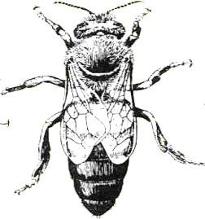Its main function is to lay eggs in the hive
* It uses the ovipositor to lay eggs
* It is much larger than the others with a large abdomen and longer legs
* It is fed on special food called ***Royal Jelly*** by special worker bees called ***Nurse Bees*** / worker bee.

**The Drone bee:**

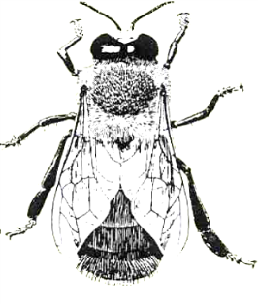Its main function is to mate with the virgin queen bee.

It fertilizes the eggs of the queen bee

**Characteristics of drone bees**

* They make a buzzing sound when flying
* They are the male bees in the hive.
* They are much larger than the worker bees, more hairy with broad blunt abdomen with no sting.

**The Worker bees:**

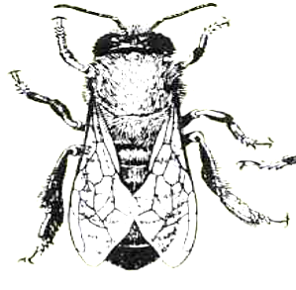They are female sterile bees in the hive

***Why?*** They cannot lay eggs and do not have the ovipositor.

They are the smallest in size but very many in number.

They do not have an ovipositor instead they have a sting.

**Their duties**

* Worker bees build combs (diagram of structure of combs)
* 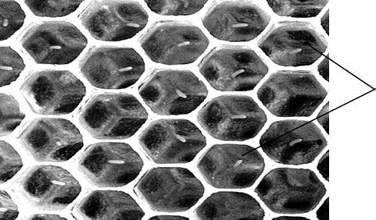They clean, guard and protect the hive

*How do they protect*?

* By stinging the enemy. *Honey combs*
* They collect nectar and feed the grubs

NB: they use their proboscis to collect nectar

* They use pollen baskets found in the hind legs to collect pollen.
* They use propolis from trees to smoothen the interior of a hive, water proof it and repair cracks

*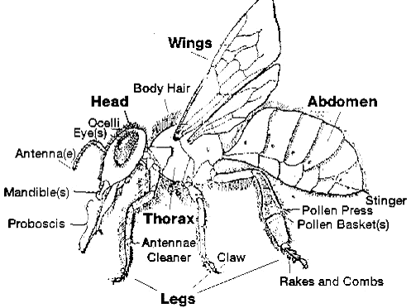Activity*

***Lesson 14***

***Parts of a honey bee***

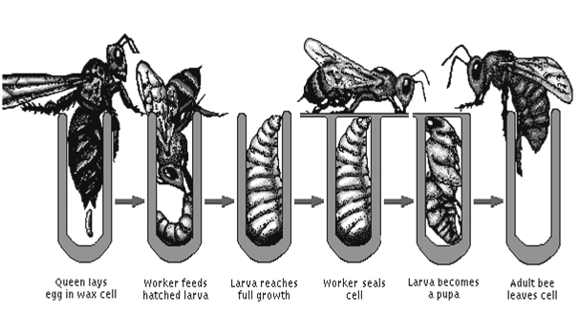***Life cycle of a honey bee***

*Honey bees undergo a complete metamorphosis.*

Activity

***Lesson 15***

**SWARMING**

A Swarm is a group of bees.

Swarming is the massive movement of bees from one place to another looking for a new hive or for a reason.

**Reasons for Swarming in bees**

* Over crowdedness of bees in the hive.
* When another queen bee is produced.
* Shortage of food and water within the area
* Dampness and bad smell around the hive.
* Presence of enemies, disease and pest around the hive.
* Overheating through direct sunlight and lack of adequate ventilation
* Disturbance and damage done to combs.
* When the queen bee has died.

**BEE HIVES**

A beehive is a natural habitat for bees.

*Common traditional beehives*

**Dug out log hive** **Kigezi bee hive**

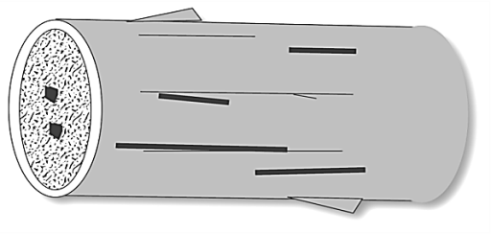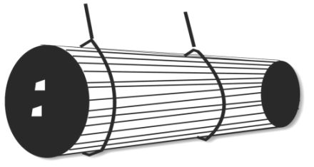

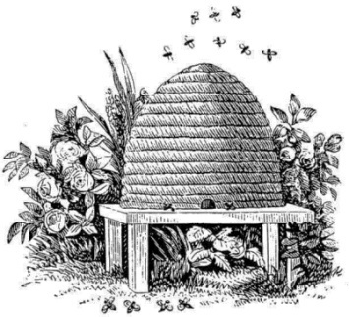

**Bee skep**

*Common modern beehives*

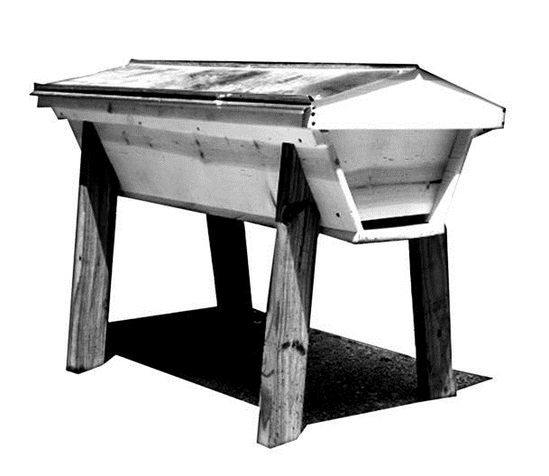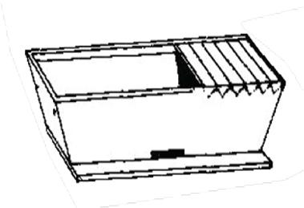**Box beehive** **Top bar hives**

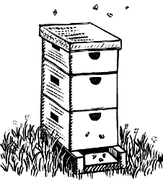

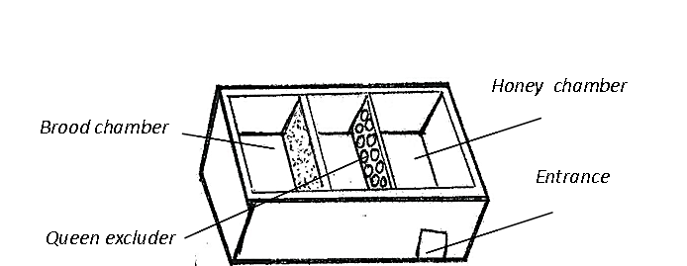

**Internal structure of a modernbeehive**

***The Brood chamber:*** The queen lays eggs and the eggs hatch into larva purpa and adult

***The Honey chamber:*** For Storage of honey and pollen

***The queen excluder***: Prevents the queen from crossing to the honey chamber and mix eggs with honey.

**Activity**

***Lesson 16***

**Siting the Hive**

This refers to the process of selecting a suitable place in which to put the hive.

**Factors to Consider when siting a bee hive:**

* A Place sheltered from strong sunlight and wind
* Presence of flowering plants around the a piary
* A Place free from noise and other disturbances
* A Place free from bee enemies.

**Stocking the hive**

Stocking refers to putting bees into an empty hive or refers to the process of encouraging bees to occupy an empty hive.

**How it is done:**

* Setting up the hive in its permanent place, Smear the inside with bee wax and wait for the bees to occupy it their own.
* Use of a catcher box
* Catching a swarm with a swarm catching net

*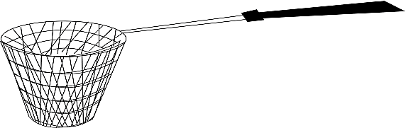a swarm catcher net*

**Feeding Bees**

During drought or in shortage of food, bees can be fed on:

1. Ordinary sugar mixed with water to make a syrup.
2. Ordinary water

Activity

***Lesson 17***

**Harvesting Honey**

Harvesting of honey is done in the evening

*Why?*All bees usually settle inside the hive in the evening.

**Equipment (Tools) when handling bees**

1. A Bee Veil
2. A Bee Keeper’s Glove – to prevent his/her hands from being stung by bees.
3. Suitable protective clothing (overall)
4. A Bucket
5. A Smoker – smoke scares and paralyses the bees; Fuel used in a Smoker: Wood shavings, old sacks, Dry grass
6. Knife
7. Gum boots

**Diagram to show a Farmer ready to harvest honey**

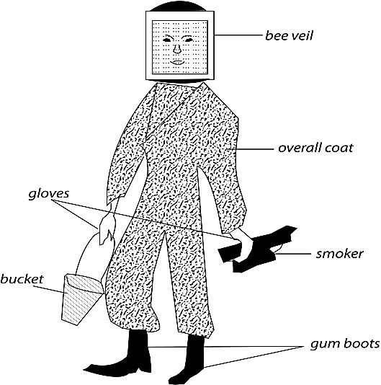

**Steps for Harvesting Honey**

1. Blow the smoke into the hive through the entrance to drive away bees
2. Lower the hive to the ground.
3. Cut and remove combs from the top to the bottom

NB: Ensure that some combs with honey remain in the hive for bees to feed on before they build new ones.

**Extraction of Honey**

Extracting honey refers to the removing of honey from the honey combs

**Methods of harvesting honey**

1. Floating the wax method
2. Pressing honey method
3. Centrifuging method of extraction of honey

***Lesson 18***

**Enemies of bees**

1. Ants e.g. wood ants, sugar ants, safari ants
2. Honey badgers – damage the hive, kill bees and eat honey
3. Wax moths – hive beetles, wasps, hawk moths.

**Products from bees**

Honey, Bee wax and pollen

**Uses of honey to man**

* Honey can be sold to get money
* Honey is used to sweeten tea and bread
* Honey is a source of carbohydrates.

**Products from bee wax**

* Candle wax
* Cosmetics
* Polish for shoes and floors.
* Match sticks.
* Lip balm, lip sticks.

**Topical test**

TOPIC 2

**MEASUREMENT**

***Lesson 19***

**MEASUREMENT OF LENGTH**

Length is the distance between two points.

Length is the measured using the following units;

Millimetre (mm)

Centimeter (cm)

Metre (m)

Decametre (Dm)

Hectometre (Hm)

Kilometer (km)

The most commonly used units for measuring length are; centremetre, metre and kilometre. The basic unit for measuring length is metre.

*Instruments used to measure length;*

Foot ruler,metre ruler, tape measure

*Activity*

***Lesson 20***

**Measurement of Area**

*This is the total surface space occupied by a figure. Area can be found after knowing the length and width of the figure*.

Length is the longer side of a figure while width is the shorter side of the figure.

Illustration

Width (W)

Length (L)

**Finding area**

Area is calculated by multiplying the longest side (length) by the shorter side (width). Length is represented by letter L and with is represented by letter W.

Find the area of the figure below

|  |  |  |  |  |  |  |  |
| --- | --- | --- | --- | --- | --- | --- | --- |
|  |  |  |  |  |  |  |  |
|  |  |  |  |  |  |  | 3 squares |
|  |  |  |  |  |  |  |  |

8 squares

Area = length x width

= L x W

= 8 x 3

= 24 square units

**NB: Basic units for area are square units** e.g. cm2, m2, km2etc

*Activity*

***Lesson 21***

**Measurement of Volume**

Volume is the space occupied by an object. Volume is measure in cubic units i.e. cm3, m3 or mm3.

Volume is also measured in litres (l), millilitres (ml) or centilitre (cl)

The basic unit for measuring volume is litre (l).

**Types of shaped objects**

There are two types of shaped objects namely;

1. Regular shaped objects
2. Irregular shaped objects

**Regular shaped objects**

These are objects which have a proper shape e.g. a cube, cuboid, blocks, tins, piece of chalk etc

Cuboid cube tin

**Irregular shaped objects**

These are objects which don’t have proper or well defined shape e.g. stones, keys, needles, shoes, sweet potato tuber, cassava tuber etc

Finding volume of regular shaped objects

The volume of regular shaped objects can be found after knowing their length, width and height. We therefore use the formular,

Volume= Length (l) x Width (w) x Height (h)

V = L x W x H

Height (h)

Width (w)

Length (l)

Example: find the volume of the cuboid shown below

3cm

2cm

4cm

V = L x W x H

V = 4cm x 2cm x 3cm

= 24cm3

Find the height of the figure below, if the volume is 36cm3

h

2cm

5cm

V = L x W x H

36 = 6 x 2 x h

36/12 = 12h/12

3cm = h

Find the volume of the figure below.

*Activity*

***Lesson 22***

Finding volume of irregular shaped objects.

The volume of irregular shaped objects is measured by using the displacement method.

There are two instruments used in the displacement method namely;

The measuring cylinder.

The overflow can (Eureka can)

It is called the displacement method because irregular object displaces the amount of water equal to its volume.

1. **Using a measuring cylinder**

Requirements;

Water, measuring cylinder, stone or sweet potato etc

Illustration string

70cc 70 cc

60cc 60 cc

50cc 50 cc

40cc measuring 40 cc

first level 30cc cylinder 30 cc

20cc 20 cc

water 10cc 10 cc 10 cc

Before after irregular

Object

Volume = second level – first level

50cc – 30cc

= 20cc

1. **Using both the overflow can and measuring cylinder**

String (thread)

Water 25cc

20cc

15cc

Irregular 5cc

object

The volume of the irregular object is 20cc.

**NB:** The importance of the string is to lower the irregular object gently in water.

Activity

***Lesson 23***

**Measurement of Weight and mass**

Weight is the pull of an object towards the earth by the force of gravity. The weight of an object is determined by the following;

Size of the object

Material from which an object is made

The pull of the force of gravity

The basic unit for weight is Newtons (N).

Mass is the quantity of matter contained in an object. Mass is constant i.e. it doesn’t change and it doesn’t depend on the pull of gravity.

The units for mass are grammes (g) or kilogrammes (kg). mass is measured using the following instruments.

* Beam balance
* Set of scales
* Scale balance
* Weigh bridge.

**Weight** is measured using a spring balance.

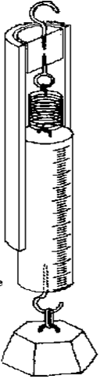

*Spring balance*

*Activity*

***Lesson 24***

**Measurement of Density**

Density is mass per unit volume. The density of an object is found after knowing its mass and its volume. The fomular for finding density is;

Density (D) = mass (m) or weight D = M

Volume V

The basic units for density are grammes per cubic units i.e.

Grammes per cubic centimetres (g/cc)/ g/cm3

Grammes per cubic mililitres g/ml3

**Densities of liquids**

Liquids have different densities.

Density of liquids is measured by an instrument called a **hydrometer.**

**Finding density**

Example: Find the density of an object of mass 150g and volume of 30cc.

Soln: D = M mass = 150g

V volume = 30cc

= 150

30 D = 5g/cc

Example

If the mass of the cuboid below is 480g, find its density.

4cm

2cm

6cm

Volume = L x W x H

= 6 x 2 x 4

= 48cm3

Density = Mass D = 480

Volume 48 Density = 10g/cm3

*Activity*

***Lesson 26***

**Floating and sinking**

**Floating**

This is when an object is put in water and it stays on top of it. Objects float on water because they are less dense than the density of water.

**OR**: Objects float on water because their density is less than the density of water.

*Examples of things which float on water include;* cork, wood, plastic, rubber, feathers, a leaf, papers, paraffin, petrol etc.

**Sinking**

This is when an object is put in water and it goes to the bottom of the water. Objects sink because their density is greater than the density of the water.

OR: Objects sink in water because they are **denser** than water.

E*xamples of objects that sink are;*stones, sand, soil, metal, glass, nails, sugar, salt etc.

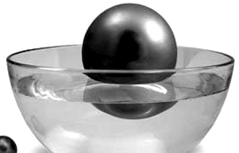

**Floating**

**NB:** A sinking object displaces water equal to its volume while a floating object displaces water equal to its weight.

*Activity*

Topic 3

**IMMUNISATION**

***Lesson 27***

**IMMUNITY AND IMMUNISATION**

Immunity is the body’s ability to resist diseases.

**Types of Immunity**

Natural acquired immunity

Artificial acquired immunity

**Natural immunity**

**How the body gets immunity naturally**

The body acquires natural immunity in two ways;

* From mother to her unborn baby
* After recovering from prolonged illness
* From the mother to her baby through breast feeding

1. *A Pregnant woman to her unborn baby*

A Pregnant woman may pass on antibodies to her unborn baby.

This particular natural immunity is called maternal immunity.

1. *Immunity from prolonged illness*

When one catches a disease, the body produces antibodies to fight the disease causing germs.

1. *Breast feeding*

A newly born baby can get natural immunity through the mother’s breast milk during suckling

**Artificial immunity**

A Person gets artificial immunity when the vaccines are introduced into one’s body during immunization.

This is mainly done by injection or by oral method. Artificial immunity is got through immunization.

**Activity**

***Lesson 28***

**Immunization**

Immunization is the introduction of vaccines into the body to make it resistant against some diseases by producing antibodies.

Antibodies

Antibodies are chemicals produced by white blood cells to defend the body against diseases.

**Why is immunization important?**

* It makes the body resistant to some disease
* It reduces infant mortality rate
* It boosts the body’s immune system against diseases causing germs
* It helps to protect children against the childhood immunisable killer diseases.

**Childhood immunisable diseases**

There are eight childhood diseases which are also called killer diseases. They attack children below six years of age.

*Why*? Their body immunity is still weak.

*Table showing disease,cause, signs,symptoms and treatment/prevention*:

|  |  |  |  |  |
| --- | --- | --- | --- | --- |
| Disease | Cause | Signs | Symptoms | Treatment prevention |
| Tuberculosis | Bacteria | Chronic cough  Loss of weight  Loss of skin colour  A lot of night sweating | Mild fever  Loss of weight  Pain in the chest or in the upper back | Treat with antibiotics  Visit a health worker for treatment  Eating a balanced diet  Isolatin |
| Measles | Virus | Sores in the mouth  Running nose  Skin rash  Dry cough  Red eyes | High temperature  Itching rash  Loss of appetite  Weakness | Isolation |
| Pertussis (whooping cough) | Bacteria | Runny nose  Severe coughing  Vomiting  Quick deep breaths through the mouth | A cold and fever at the beginning | Use of antibiotics |
| Diphtheria | Bacteria | Swollen neck  Sore throat | Fever  Difficulty in breathing | Prevent through immunization  Seek medical treatment  Isolation |
| Tetanus | Bacteria | Stiff muscles  Sudden and strong  Tightening of muscles when touched  Baby stops sucking | Fever | Immunization  Wounds and cuts should be dressed  Using only clean cutting objects during birth |
| Polio (poliomyelitis) | Virus | Lameness of the bones | Paralysed limbs | Drinking boiled water  Proper disposal of faeces  immunization |

***Activity***

***Lesson 29***

**Vaccines**

Vaccines are special drugs introduced to the body to make it produce antibodies against specific diseases.

**Types of Vaccines**

There are three types of vaccines namely:

* Toxoids (poisonous substance),
* Attenuated (weak disease causing germs),
* Killed vaccines (dead disease causing germs)

|  |  |  |  |
| --- | --- | --- | --- |
| **Vaccine** | **Age at which vaccine is given** | **Disease protected against** | **How the vaccine is administered** |
| BCG | At birth | Tuberculosis | Injection on the right upper arm |
| Polio vaccine | At birth  6 weeks  10 weeks  14 weeks | Polio | Putting drops in the mouth |
| DPT  Hep B + Hib | 6 weeks  10 weeks  14 weeks | Diphtheria  Pertussis(whooping cough)  Tetanus  Hepatitis B  Haemophilus  Influenza type b | Injection on the left thigh |
| Measles vaccine | 9 months | Measles | Injection on the left upper arm |

*Activity*

***Lesson 30&31***

*Other immunisable diseases*

**Cholera**

* Caused by bacteria.
* Spread through contaminated water and food.
* Food can be contaminated by house flies.

**Signs and symptoms**

* Serious colorless watery diarrhoea
* Vomiting violently
* Cramps, shock and dehydration
* Weakness

NB: Cholera breaks out in an area as an epidemic disease. An *epidemic disease* is a disease that breaks out in an area with very many signs and symptoms.

Note: Talk about endemic and pandemic diseases.

Cholera can lead to severe dehydration that may lead simultaneous death if not treated.

*Dehydration* is a condition when the body does not have enough water in it.

**Causes of dehydration**

* Severe diarrhoea
* Severe vomiting
* Diarrhoea and vomiting can lead to loss of water and important salts, sodium and potassium.

**Signs of dehydration**

* Sunken eyes
* Dry mouth
* Sunken fontanelle(soft spot on the baby's head)
* Little or no urine is passed out
* A pinch of the skin goes back to shape slowly
* A person feels sleepy and irritable.

**Treatment for Dehydration**

* Give plenty of fluids
* Give ORS

**How to mix ORS (SSS) at home**

1. Wash hands with clean water and soap.
2. Measure a litre of boiled but cooled water in a container.
3. Measure one leveled tea spoon of salt and eight leveled teaspoons of sugar into the container of water.
4. Mix the salt and sugar into the water to make a solution.
5. Taste the solution, it should never taste salty.
6. Give the drink to the person with diarrhoea or dehydration.

**When making ORS;**

* Water works as the solvent
* Salt and sugar work as solutes

**Prevention and control of cholera**

* Immunization
* Drink clean boiled water
* Cover all food to avoid houseflies
* Take the infected person to the hospital as soon as possible
* Use latrines to dispose faeces
* Wash hands before eating food and after using the latrine
* Reheat all cold foods
* Observe good food hygiene

**Meningitis**

* Caused by bacteria
* Spread through air

**Yellow fever**

* Caused by a virus
* Spread by the aedes or tiger mosquito

**Small pox**

* Caused by a virus
* Spread through air

**Note:**Edward Jenner an English Doctor was the first to discover the vaccine and vaccination of small pox in 1700.

**Typhoid**

* Caused by salmonella typhi
* Spread through contaminated water or food by a housefly

**Influenza**

* Caused by a virus
* Spread through air

**Rubella (German measles)**

* It is a highly infectious disease which causes a rash and fever
* It usually affects older children and adolescents.

**Typhus fever**

* Caused by bacteria
* Spread when lice/ticks bites an infected person and then it bites a normal person

**Plague**

* Caused by bacteria
* Spread by rat fleas

**Rabies**

* Caused by a virus which affects the nervous system
* Spread by a bite of an infected dog or fox

**Importance of a child health card**

* It reminds the parents of the next date of immunization
* It enables parents monitor the growth of their child
* It enables the doctor to know which dose has been given and what is remaining.

***End of topic test***

Topic 4

**HUMAN DIGESTIVE SYSTEM**

***Lesson 32***

**Human digestive system**

Digestion is the process by which food is broken down into simple soluble particles which can be absorbed by the body.

**Types of digestion**

i) *Mechanical/Physical digestion*

This is the process of breaking down food into small particles by teeth.

Mechanical digestion takes place in the mouth.

ii*) Chemical digestion*

This is the process of breaking down food into smaller particles by the enzymes. Chemical digestion starts from the mouth to the ileum.

**The alimentary canal**

It is a muscular tube running from the mouth to the anus. It is part of the digestive system. The alimentary canal is composed of the following parts;

Mouth, gullet, stomach, duodenum, ileum, colon, appendix, rectum and anus

**The digestive system (diagram)**

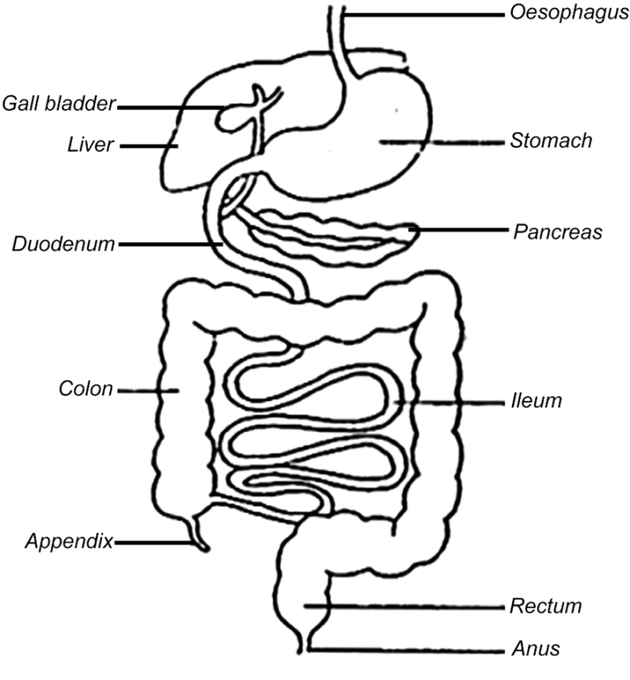

***Lesson 33***

**Functions of the different parts**

**The mouth**

**Teeth:**

Break down food into smaller particles

1. Incisor-cutting or biting food.
2. Canines-tearing food
3. Pre-molars and molars-grinding,crushing or smashing food.

**Tongue:**

* Tastes food
* Rolls the food into bolus.
* Pushes food into the gullet.

**Epiglottis**

It is the finger-like structure that prevents foreign particlesfrom entering the trachea.

**Soft palate:**

Prevents food from entering the nasal cavity

**The Stomach:**

* Temporary store for food.
* Produces gastric juice.
* Produces hydrochloric acid.
* Absorbs alcohol**.**

**The pyrolic sphincter**

It is a strong muscle that holds food in the stomach and lets it into the duodenum at intervals.

**The liver**

* Produces bile juice.
* Changes poisonous substance that come with blood into harmless ones.
* Stores certain foods e.gcarbohydrates,iron,VitaminAand D.
* Stores blood.
* Controls the sugar level in blood.

**Gall bladder**

Stores bile salts

**The pancreas**

Produces pancreatic juice

**The ileum**

* Produces intestinal juice.
* Final digestion takes place here.
* Absorption of digested food takes place here.

**The colon:**

Absorption of water from undigested food takes place here.

**Rectum**

Temporary store for undigested food until it is released through the anus.

**Anus**

Passes out undigested food as faeces

**Activity**

***Lesson 34***

**Enzymes**

Enzymes are chemical substances in the body that speed up the rate of the digestion of food.

**Characteristics of enzymes**

• They are specific in nature. i.e lipase works on lipids.

• They always form the same end products.

• They work best in a narrow temperature range

* Enzymes are proteins in nature

• Enzymes work in a particular condition i.e some in acidic and others in alkaline condition. i.e salivary amylase, trypsin, lipase and intestinal enzymes work in alkaline condition while pepsin and renin work in acidic condition.

**Digestion in the mouth**

In the mouth, food is broken by teeth and mixed with saliva to lubricate it for easy swallowing. Chewed food is rolled into bolus by the tongue and pushed into the gullet.

Saliva is produced by the salivary glands. It contains an enzyme called salivary amylase or ptyalin which acts on cooked starch.

Food is broken down into smaller particles through chewing. Saliva is mixed with the food to soften it.

During swallowing, the epiglottis closes over the opening of the trachea to prevent food from entering into it.

**Food in the gullet (oesophagus)**

The gullet is a muscular tube that passes food from the mouth to the stomach. Food is pushed through the gullet into the stomach by a process called peristalsis.

**Food in the stomach**

Food is thoroughly churned into chyme by the action of peristalsis of the stomach. The walls of the stomach produce a juice called gastric juice and hydrochloric acid. The work of the hydrochloric acid is to kill any germs which escape with food during swallowing. Gastric juice contains two enzymes;

* Pepsin which digests proteins
* Rennin which clots milk in babies.

No absorption of food takes place in the stomach apart from little water, salt, alcohol, little glucose and some medicine.

Activity

***Lesson 35***

**Digestion of Food in the duodenum**

* The duodenum receives bile juice through the bile duct.
* Bile juice is produced by the liver and stored in the gall bladder.
* Bile juice doesn’t contain any enzyme but contains bile salts. The work of bile salts break down fats into tiny droplets for easy digestion.
* The duodenum receives pancreatic juice through the pancreatic duct.
* The pancreatic juice is produced by the pancreas. It contains the following enzymes; pancreatic amylase, trypsin, and lipase.
* No absorption of food takes place in the duodenum.
* The first food to be digested in the duodenum is fats

.

**Food in the ileum**

Digestion of food is completed here and the digested food is absorbed in the body. Absorption is the process by which digested food is taken into the blood stream. The walls of the ileum produce an intestinal juice which contains enzymes that complete the digestion of food. The ileum has structures called villi through which digested food passes to enter the blood. The hepatitic portal vein takes blood rich in digested food from the ileum to the liver.

**The small intestine**

There is no digestion in the large intestine, no enzyme is produced here. Absorption of water takes place in the colon. The undigested food is passes out through the anus as feaces, stool or excreta.

***Lesson 36***

**Diseases and disorders of the digestive system**

**Diseases**

* Appendicitis
* Peptic ulcers
* Cholera
* Typhoid
* Dysentery
* Diarrhoea

**Disorders**

* Constipation
* Indigestion
* Intestinal obstruction
* Vomiting

***Lesson 37***

**Food hygiene**

This is the way of keeping food clean.

**Ways in which food is made dirty**

* Handling it with dirty hands.
* When houseflies land on the food
* Putting food in dirty containers
* Leaving food uncovered and dust drops on it.

**How to prevent food contamination**

* Washing hands before handling food.
* Always keep leftover food covered.
* Keeping food in clean containers.
* Serving food from clean places
* Heating or reheating the food to kill germs.

**Good eating habits**

* Washing hands before eating food
* Chew food properly and eat slowly
* Do not talk while eating
* Eat food that make up a balanced diet
* Have regular and healthy meals
* Wash hands after eating food
* Never eat left over smelly food
* Wash fruits and vegetables before eating
* Do not eat food that has dropped on the ground
* Eat well cooked food for easy digestion

**Dangers of bad eating habits**

* Swallowing big lumps of food can cause choking.
* Eating hurriedly can result into constipation and stomachache.
* Talking with mouthful of food one can bite his/her tongue, can swallow un chewed food that can cause choking.
* Biting very hard things can damage the teeth.
* Drinking too much liquid while eating prevents one from eating enough food and also can dilute digestive juices.